|  |
| --- |
| Abbott Laboratories |
| Front End Pressure Prognostic Health Monitoring (PHM) Algorithm for Faulty Pressure Transducer |
| ICQ Immunoassay Analyzer Pipettor Pressure Monitoring |
|  |
| **Version 1.0** |
| **10/27/2016** |

|  |
| --- |
|  |

Table of Contents

1. Purpose 2

2. Introduction 2

2.1. Scope 2

2.2. Alert Profile 2

2.3. Overview 2

2.4. Abbreviations 3

3. Data 3

3.1. Source 3

3.2. Scores 4

4. Alert 5

4.1. Data Processing Steps 5

4.2. New Threshold 6

4.3. Alert Details 6

4.4. Root Cause 6

4.5. Action Needed 6

5. Supporting Evidence 7

5.1. Field Data Analysis 7

6. Benefits 12

7. Applicable Documents 13

7.1. Specification Documents 13

7.2. Past Investigations 13

7.3. Assemblies 13

7.4. System Requirement 13

7.5. Hazard Analysis 13

# Purpose

To implement a Prognostic Health Monitoring (PHM) algorithm for the ICQ-Immunoassay (ICQ-IA / Alinity-i) Analyzers that will detect a degrading pipettor pressure transducer or loss-of-connection to the controller board and associated loss of pressure monitoring before the customer begins experiencing an increase in pipetting errors and/or erratic results due to inaccurate pipetting.

# 2. Introduction

## Scope

This document describes the recommended specifications for the Pipettor Pressure Monitoring (PM) Front End (FE) Pressure, Prognostic Health Monitoring (PHM) alert for the ICQ-Immunoassay Analyzers.

## Alert Profile

|  |  |
| --- | --- |
| PHM Alert | FE Pressure |
| Future PHM Alert Code | TBD by Service |
| Threshold | FE Pressure greater than 27,000 or less than 21,000 |
| Platform | ICQ-IA Manufacturing Prototypes |
| Data Source | IDA |
| Notification | Daily Report / Instrument Serial Number / Pipettor |
| Analysis Frequency | Daily |
| Confidence Rating | 99% |
| Failure Prediction (remaining useful life post-alert) | Unknown |
| Recommended Action | Above 27,000: Consider replacement of pipettor pressure sensor.  Below 21,000: Inspect pipettor board, all connections, and the pressure sensor. Consider replacement of pipettor pressure sensor |

## Overview

The Pressure Monitoring system is a critical, safety-related mode of control for the ICQ-IA Analyzers. The purpose of pressure monitoring (PM) is to provide a level of confidence that there are no errors by the pipetting system during fluid aspirations. The PM system is designed to detect clogged probes, air aspirations, and bubbles. By measuring and analyzing the pressure signal during aspiration, these errors are detected and communicated to the system. These measurements are accomplished by placing a pressure transducer in the fluid line between the syringe and probe. At aspiration time, the syringe motor profile (velocity, acceleration and motor steps) and thresholds are communicated to the LLS/PM board from the Module Controller CPU. Given this information, the pressure profile is analyzed for abnormalities compared to expected values derived from the given information. If anomalies in the pressure profile exceed predetermined thresholds, the associated sample result is sent to exception.

## Abbreviations

|  |  |
| --- | --- |
| FE Pressure | Front End Pressure |
| IA | Immunoassay |
| IDA | Instrument Data Analytics |
| PHM | Prognostic Health Monitoring |
| PM | Pressure Monitor |
| PT | Pressure Transducer |
| ODR | Onboard Data Recorder |
| SCC | System Control Center |



# Data

## Source

ICQ IA Pipettor Pressure Monitoring data is collected with every aspiration from all 3 pipettors (see Figure 1). Algorithms are used to reduce the raw data profile to 7 calculated indices that are sent to the instrument ODR. The ODR then transmits the data to the BSQD1I IDA via AbbottLink. For instruments whose data is being collected into the IDA, the scores can be accessed in the ODR_PMEVENTSICQ table. Raw pressure profiles can be accessed by linking together ODR_PMRAWDATAICQ and ODR_PMRAWDATAREADSICQ (by ParentID and DateTimeStamp).

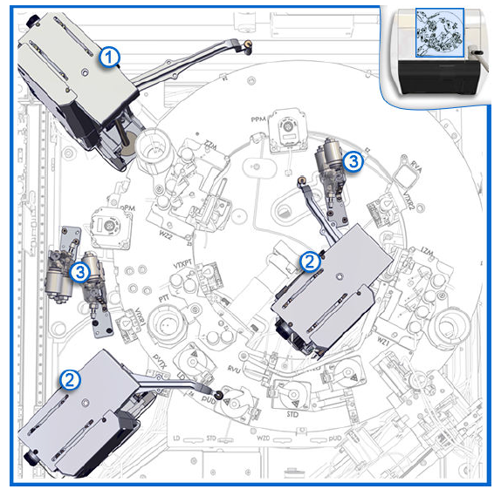  
*Figure 1. Diagram displaying pipette locations (taken from the Q Immunoassay and Clinical Chemistry System Operations Manual)*

Legend for Figure 1:  
1. Sample pipettor.  
2. Reagent1 and Reagent2 pipettors.  
3. Wash cups (Sample Wash, Reagent1Wash, Reagent2Wash).

## Scores

Filtering algorithms are applied to all points in the profile, which can be as many as 700 points. These are distilled further into indices (called "scores") that provide estimates of the quality of the aspiration process. All scores are treated as independent parameters, in that each provides insight into a different aspect of the aspiration success or failure. By applying a threshold to each index, profiles are distinguished as being at risk for inaccurate volumetric recovery. The scores calculated are:

|  |  |
| --- | --- |
| **Score** | **Definition** |
| Front End (FE) Pressure | The ambient pressure is called the Front End, or FE. This is calculated by averaging the filtered output of fifty data points, sampled at ambient pressure prior to syringe movement. |
| Back End (BE) Pressure | The pressure is calculated by averaging the filtered output of fifty data points after the syringe stops. This residual pressure is called the Back End, or BE. |
| Shape Score | The shape score is the degree of pressure variation experienced by the sample during the syringe movement. Whereas normal fluid aspirations should be stable in this period, aspiration faults due to Foam & Partial Aspiration are detected by calculating the number and degree of unexpected abrupt pressure changes. A metric for this characteristic is calculated by the PM algorithm. If the result exceeds a threshold, an aspiration fault is asserted. (Shape Score Fault) |
| PSI Discord | The PSI Discord score compares the FE pressure to the reduced pressure during the aspiration itself. This lowered pressure is calculated from the averaged value of fifteen (15) points during the stable period of the aspiration, and is intended to evaluate if the vacuum pressure developed by the syringe is sufficient to support aspirating the fluid volume requested. Air-only aspirations produce a different range of scores, allowing for thresholds to separate the desired aspirations of fluid from aspirations involving air. If the developed vacuum (and thus, the PSI Discord score) exceeds predetermined minimum or maximum thresholds, an aspiration fault (PSI Discord Fault) is asserted. |
| Clot Score | The Clot Score is the degree of probe blockage, measured as the residual vacuum pressure after the syringe has come to rest. A clot or other probe clog is detected by comparing the pressure immediately before (FE) the syringe movement to afterwards (BE). When the difference between them exceeds a pre-determined threshold, an aspiration fault (Clot Score Fault) is asserted. |
| Slope Score | The Slope Score is an assessment of pressure drift trending during the time that the syringe is moving at a constant speed. A slope in this characteristic indicates that elastic fluid (air) has been aspirated instead of liquid, causing a gradual decrease in vacuum over the aspiration time. The algorithm is set to assert an aspiration fault if this pressure loss exceeds its pre-assigned threshold. (Slope Score Fault) |
| Aspirate Pressure | The Aspirate Pressure is the arithmetic mean of the bottom of the bathtub. This is the equivalent of Z-mean in Figure 2 |

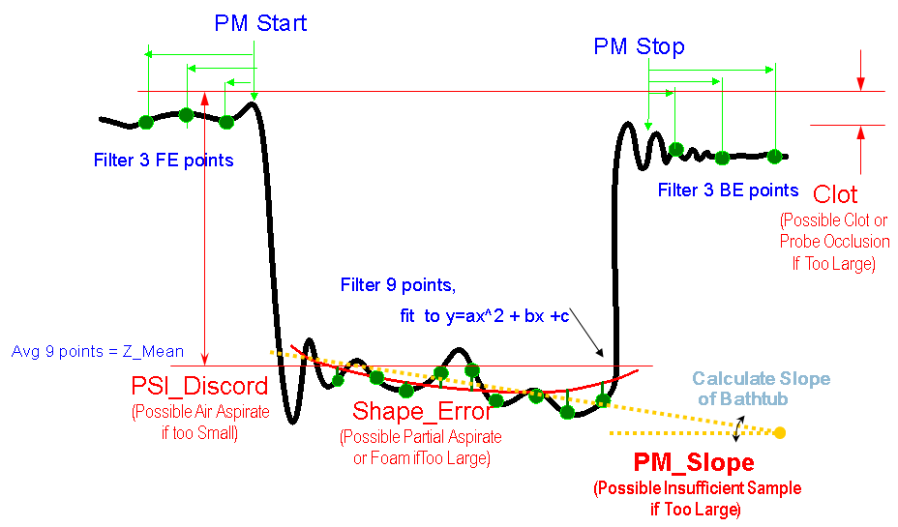  
*Figure 2. Profile of an individual pipette pressure profile from the ARCHITECT era, which was modified for Q purposes.*

# Alert

## Data Processing Steps

|  |  |
| --- | --- |
| Data Processing Steps | |
| 1 | Query all the data for the last 24 hours for each pipette (IDA Table: ODR_PMEVENTSICQ) |
| 2 | Unique pipettors will be identified by MODULESNDRM and PIPETTORMECHANISMNAME |
| 3 | Exclude aspirations with: PIPETTINGPROTOCOLNAME = "NonPipettingProtocol" |
| 4 | Exclude pipettors that have less than 10 aspirations |
| 5 | Summarize the data by calculating the Minimum and Maximum FE Pressure value (FRONTENDPRESSURE for each pipettor for that 24 hours |
| 6 | Flag any pipettor with a FE Minimum below 21,000 or a FE Maximum above 27,000 |

## New Threshold

The below threshold is the proposed new alert:

|  |  |  |
| --- | --- | --- |
| Score | Lower Threshold | Upper Threshold |
| Front End Pressure | **21,000** | **27,000** |



## Alert Details

FE Pressure data will be collected for all pipettors that are in the field, and have data available in the IDA. For each pipettor, a daily minimum and maximum FE Pressure value will be calculated. If any pipettor has a value during that day for FE Pressure that falls below 21,000 or above 27,000, the FE Pressure Alert will be generated. The rationale for not requiring consecutive days is to quickly flag pressure transducers that may require replacement or have a faulty connection back to the controller board.

## Root Cause

The FE pressure varies among sensors, but most maintain a range of 23,000-25,000.  Since FE pressure is a measure of ambient pressure that occurs prior to the movement of the syringe, it is expected to be consistent. For now, the majority of sensor failures appear to be immediate without an identifiable trend beforehand, suggesting most prototype failures have been random failures rather than wear-out. Additionally, sensor abnormalities in the ICQ IA system can leave the normal range either above or below.

When these same sensors were utilized on ARCHITECT where sensors would fail above normal range, which could potentially explain one failure mode. The working theory behind this historical upward drift in FE pressure was that the channel in the insert became occluded.  This is due to swelling of the media seal, tolerances, or both. The occlusion causes reduced response sensitivity and can result in changes to the other scores and increased aspiration errors. Newer versions of the PM sensor changed the center insert to prevent one of the internal seals from occluding the fluid flow channel to the sensing element. It is unlikely, however, that this change ended all cases of drifting FE pressure and this type of failure mode.

Unique from ARCHITECT systems, the ICQ IA pressure sensor can fall below the normal range and reach a “floor” value. The working theory behind this FE pressure is an electrical loss-of-connection between the sensor and the controller board. As this type of abnormality is not isolated to the sensor itself, it instead requires analysis of the board, connections between the board and sensor, as well as the sensor itself to correct the issue.

## Action Needed

Pipettors that are flagged with the FE Pressure alert should be scheduled for examination during the next visit. Examination should include checking connections and cords between the controller board and the pressure sensor for possible faults. Replacement of the pressure transducer should be considered for the next scheduled visit.

# Supporting Evidence

## Field Data Analysis

Field Instrument Pipettor PM data was queried from the IDA for Manufacturing Prototypes with the most recent pipettor specifications. The query resulted in 557,753 individual FE Pressure Measurements obtained from 18 instruments and 54 unique pipette locations. Minimum and Maximum FE Pressure values were evaluated by instrument, pipettor, and day. If there were less than 10 aspirations measured on a sensor per day, the ceiling or floor values were detected, that day’s data was excluded. Of the 855 sensor-days of data available, 62 sensor-days were excluded in this manner. Removing these known failures, analysis shows that with 99% confidence that 99% of the population of pipettors will have an FE Pressure value between 22,846 and 25,016. With 99%confidence covering 99.5% of the population, an FE Pressure value between 22,748 and 25,113 is expected. See Figures 2 & 3 below:

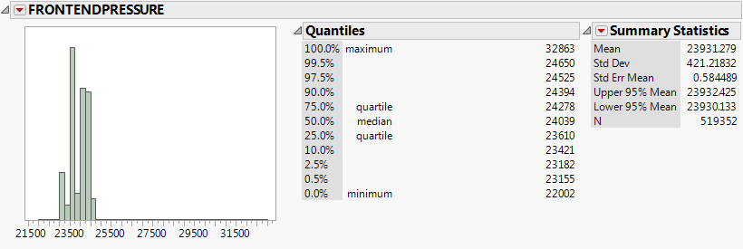 *Figure 2: Distribution of Front End Pressure values across MP instruments. Values were excluded from analysis if there were less than 10 aspirations in a day, the ceiling value was reached, or the floor value was reached.*

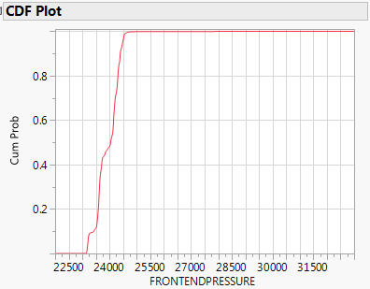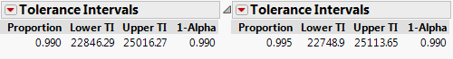

*Figure 3: CDF (Cumulative Distribution Function) Plot shows the cumulative probability that a value will occur. A tolerance interval contains at least a specified proportion of the population. It is a confidence interval for a specified proportion of the population. Below, it is set to include with 99% confidence, 99% and 99.5% of the population of FE Pressure scores.*

While the CDF and tolerances for ICQ-IA data are tighter than ARCHITECT era data, it is a much smaller dataset based upon a limited number of prototypes. ARCHITECT data previously indicated that values exceeding 27,000 are abnormal and that the FE Pressure value will continue trending up towards a FE Pressure “ceiling" failure mode. As the pressure monitoring values on ICQ-IAMPs were set to reflect ARCHITECT values and the ARCHITECT-era upper limit of 27,000 was determined on a larger production-era population, utilizing this limit would be a more conservative choice than what is indicated by ICQ-IA data. Notice that similar to ARCHITECT, FE Pressure hits a “ceiling” that is currently understood to be 33,299 based upon available data (see Figure 4). The equivalent “floor” value that ICQ-IA sensors can reach is believed to be 14,274 (See Figure 5). At this point, the pressure transducer has been literally “maxed out.” This should result in an increase in aspiration errors such as PSI discord violation.

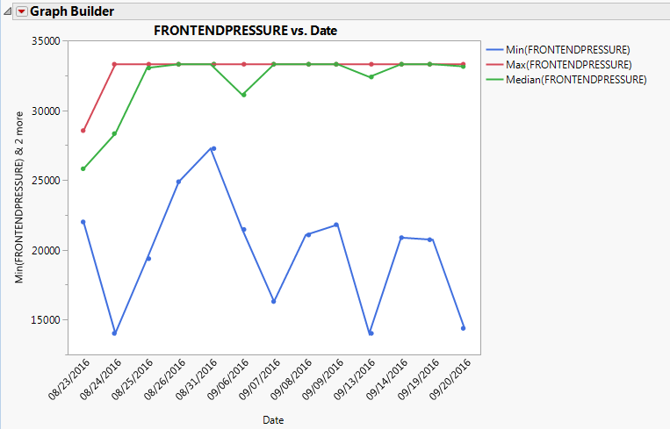

*Figure 4: A plot of the daily minimum (Blue dots/line), maximum (red) and median (green) over time. Note the increase in maximum and median values for the sensor, with both values fluctuating near 33,299.*

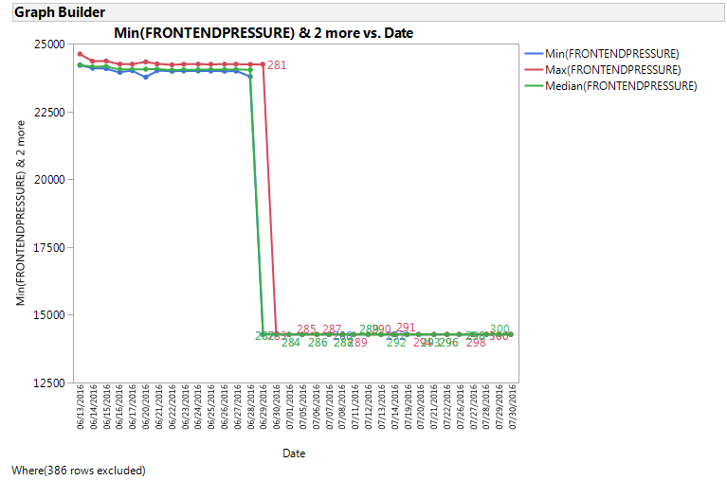

*Figure 5: A plot of the daily minimum (Blue dots/line), maximum (red) and median (green) over time. Note the failure event of the sensor, which lead to FE pressure values fluctuating near 14,274.*

Currently, there are no cases in the RSLMS of an effective replacement of a pressure sensor on a Verification or Manufacturing Prototype during an out-of-range event which brought the FE Pressure back to normal levels. One case on a MP failed to rescue FE Pressure with a suggestion that the controller board was at fault (RSLMS-93834, Figure 6). This would suggest that FE Pressure hitting the “floor” may be due to a connectivity issue between the sensor and controller board. As in the case of RSLMS-93834, this connection fault may not be at the sensor itself. During an experiment in the PHM lab with a Verification Prototype, the instrument was run with a normally operating sensor unplugged from the controller board and then re-connected (Figure 7), corroborating that “floor” values are due to connectivity issues between the sensor and controller board and can be returned to normal by re-establishing the connection. Once the pressure transducer is replaced in the case of a “ceiling” failure mode, the following real example from an ARCHITECT instrument (Figure 8) shows what is expected, which is that the FE Pressure returns back down to the normal level.

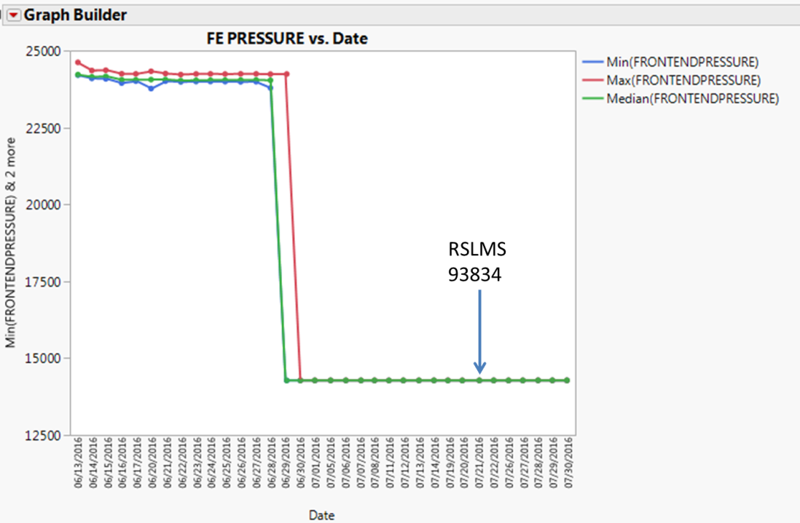

*Figure 6: An out-of-range FE pressure value from a pressure sensor. The pressure sensor was replaced, but did not bring the FE pressure back into a normal range. The RSLMS entry suggested the pipettor board may have been faulty, but no further action was recorded.*

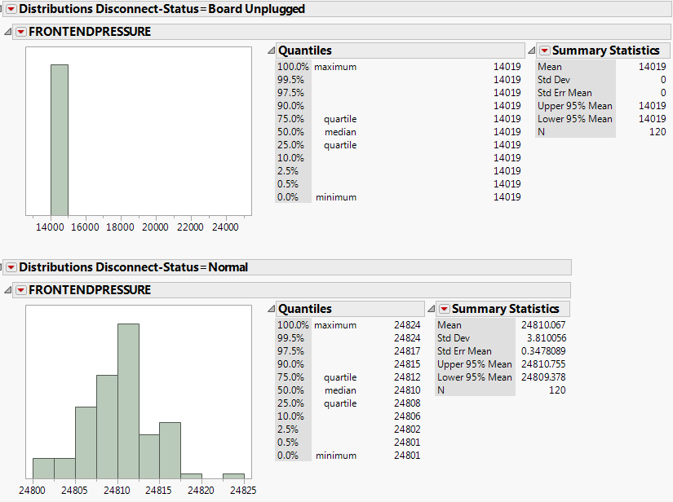

*Figure 7: FE Pressure values reported from a normally operating pressure sensor when unplugged from the controller board (above), and when plugged in (below).*

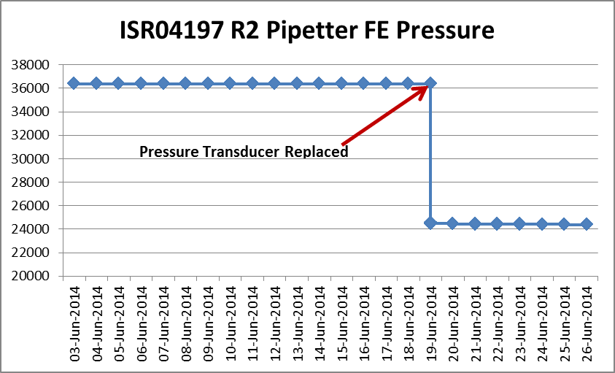

*Figure 8: An out-of-range FE pressure value from an ARCHITECT pressure sensor. The pressure sensor was replaced at the indicated date (see arrow), which brought the FE pressure back into a normal range.*

A capability analysis shows that with a lower spec limit on FE Pressure of 21,000 and upper of 27,000 we can expect that *currently* approximately 6.7% of all aspirations from pipettors in the field will fail this proposed threshold (see Figure 9). As this includes many repeated flags in the same day, 3 specific pipettors (of the 54 total in the dataset) would have flagged based upon these spec limits between June and September of 2016.

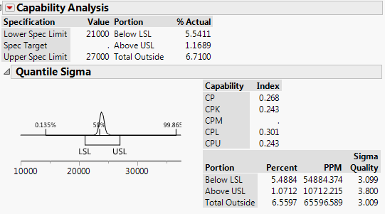

*Figure 9: Capability analysis report of the recommended tolerances on all ICQ-IA Manufacturing Prototype data available with ARCHITECT-scaled values December 2015 through September 2016.*

# Benefits

The benefits of correcting the sensor issue-which may involve replacing the pipettor pressure sensor-when FE exits the normal range can be summarized as follows:

Prevent reactive service visits related to tests lost due to aspiration errors.

Prevent multiple reactive service visits (with the incorrect or not all failing pipettor parts replaced).

Prevent reactive service visits related to erratic results due to insufficient aspirations (by rescuing the pressure monitoring capability before it is no longer working as a mode of control for aspirations).

Proper functionality of a critical, safety-related instrument mode of control.

The investigation of past tickets and instruments with high FE Pressure show that pipettors with high FE Pressure are more likely to develop pipetting problems, generate error codes, and send tests to Exception, which eventually will result in a reactive service ticket.

In addition, at times the incorrect part is replaced (for example, the probe), which doesn’t remedy the problem and the problem continues, leading to another reactive service ticket and further customer inconvenience and expense to the Service Organization.

# Applicable Documents

## Specification Documents

S900145-102 i1000SR LLS/PM Board Specification Document (DOORS)

Note: This information was developed by Jim Vaught and is taken from the released document: i2000/i2000SR Aspirate Monitoring (PM) Theory of Operation, SUPDOC.D33, Version 1. Changes include adding references to i1000sr.

## Past Investigations

Case Study and Review for the Pressure Monitor Sensor Failure – Popeye Cheung, June 6, 2012 “LOG-IC 4.1 Reference Guide” (p158-165) 202850-104, Dec.2011 (Powerpoint presentation from the Asia-Pacific Service and Support conference, 2012) and ISA 116-041 (Global Service Reports database).

## Assemblies

|  |  |
| --- | --- |
| 732560 | PM Sensor, i1000SR, PAD |

## System Requirement

GDR38.D02-315 (DOORS): The PM system shall monitor the pressure of aspirated liquid during an aspiration event, analyze the pressure data for abnormalities, and store the analysis result in I/O registers.

## Hazard Analysis

From HA.D05 Hazard Analysis (DOORS):

|  |  |  |  |  |  |  |
| --- | --- | --- | --- | --- | --- | --- |
| Hazard #  Number | | | Source | Cause | Detail Design Item | High Level  Design Item |
|  |  |  |
| 67 | | | Sampling error, Incorrect volume of sample pipetted | Misalignment of specimen  container at pipetting  location. | 4.9.2.4 | 4.7.1 |
| 189 | | | Cracked or Leaking Sample Cup causes incorrect patient result | Undetected leaking sample container on system | 4.9.2.4 | 4.7.1 |
| 275 | | | Leaking or cracked reagent containers | Leaking or cracked reagent containers | 4.9.2.4 | 4.7.1 |
| 316 | | | Coring of Immunoassay reagent bottle by probe | Plugging of reagent probe by  particulate matter causes reagent dispense error. | 4.9.2.4 | 4.7.1 |
| 344 | | | immunoassay System - incorrect Sample Volume Aspiration | Sample flu d sensed without probe being in fluid, e.g.- hanging drop causes flu d sense on wall of container or above specimen level, or foam on surface causes level sense above specimen level. | 4.9.2.4 | 4.7.1 |
| 346 | | | immunoassay System - incorrect Sample Volume Aspiration | Plugging/obstruct on of aspiration probe causes aspiration failure. | 4.9.2.4 | 4.7.1 |
| 376 | | | immunoassay System - incorrect Sample Volume Dispense | Probe Blockage-dispense compromised due to blockage of probe. | 4.9.2.4 | 4.7.1 |
| 432 | | | immunoassay System - incorrect Volume Transfer – Reagent Aspiration | Plugging/obstruction of  aspiration probe causes aspiration failure. | 4.9.2.4 | 4.7.1 |
| 434 | | | immunoassay System - incorrect Volume Transfer – Reagent Aspiration | Bubbles/ foam on reagent  causes inappropriate level sense. | 4.9.2.4 | 4.7.1 |
| 461 | | | immunoassay System - incorrect Volume Transfer – Reagent Dispense | Dispense probe blockage causes improper dispense. | 4.9.2.4 | 4.7.1 |
| 468 | | | immunoassay System - incorrect volume transfer - Pre-dilute | Plugging/obstruction of probe during aspirate of predilute specimen causes incorrect aspirate event. | 4.9.2.4 | 4.7.1 |
| 494 | | | immunoassay System - Line  Buffer to Reagent Cross-contamination | Valve/syringe/tubing failure resulting in loss of vacuum and leaking, dripping, or movement of fluids within fluid path at incorrect time. | 4.9.2.4 | 4.7.1 |
| 520 | | | immunoassay System - Dilution of reagent with Wash Buffer | Valve/ Syringe/ Tubing Failure such that fluid cannot be retained properly in probe  causing dripping or formation of hanging drops. | 4.9.2.4 | 4.7.1 |
| 1008 | | | immunoassay System - Process  Path integrity compromised due to static electricity | Static charge on liquid in  reaction vessel causes level sense error. | 4.9.2.4 | 4.7.1 |
| 1180 | | | inadequate serum/ specimen volume above clotting agent in specimen tube | User does not place sufficient  volume of specimen material in specimen container such that aspiration probe contacts gel (serum) separator material  during sampling. | 4.9.2.4 | 4.7.1 |